Implementing and Managing Always on Availability Group in SQL Server 2014/2016/2017/2019:

Always on introduced in SQL Server 2012 provide high availability for our application databases.
Availability group allows you to failover a group of databases together and allows configuring multiple databases as replicas to which you can failover, thereby increasing the redundancy and availability.
The availability group contains a set of SQL Server instances called “Availability Replicas”. Each availability replica possesses a local copy of each of the databases in the availability group. Only one of these replicas acts as the primary replica at any point of time and maintains the primary copy of each of the databases. The Primary replica makes these databases, known as Primary databases, available to users for read/write. For each primary database one or more available replicas is called Secondary Replicas, maintains a copy of the database and databases on this replica would be referred to as Secondary databases.
In this document we will be having three servers known as SQLONE as Primary and SQLTWO and SQLTHREE as Secondary Replica.
Pre-Configuration Validation:
- Check whether cluster failover services are working fine or not.
- Check whether all cluster disks are online or not.
- Check whether my Cluster is online.
- Enable the Always ON Availability feature in SQL 2012.
Follow the below steps to accomplish the validation task:

Click on the Server Manager as shown in the screenshot.

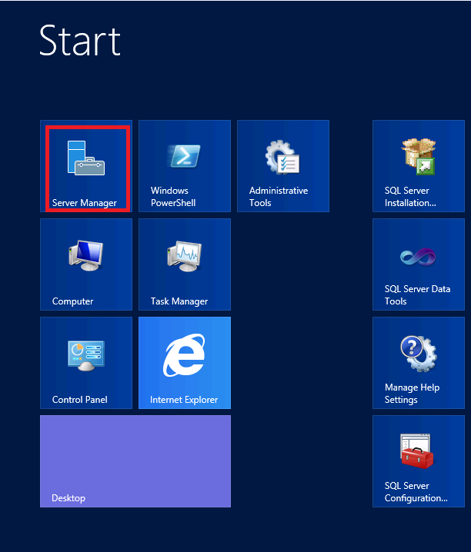
Click on “tools” option in the server manager console and select the “Failover Cluster Manager”.
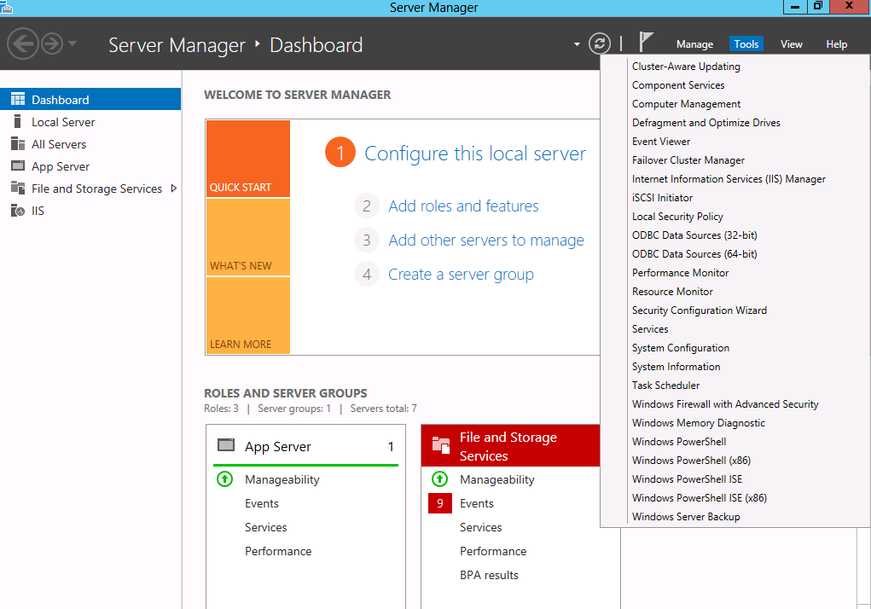

Click on the Failover Cluster Manager and expand the tree.
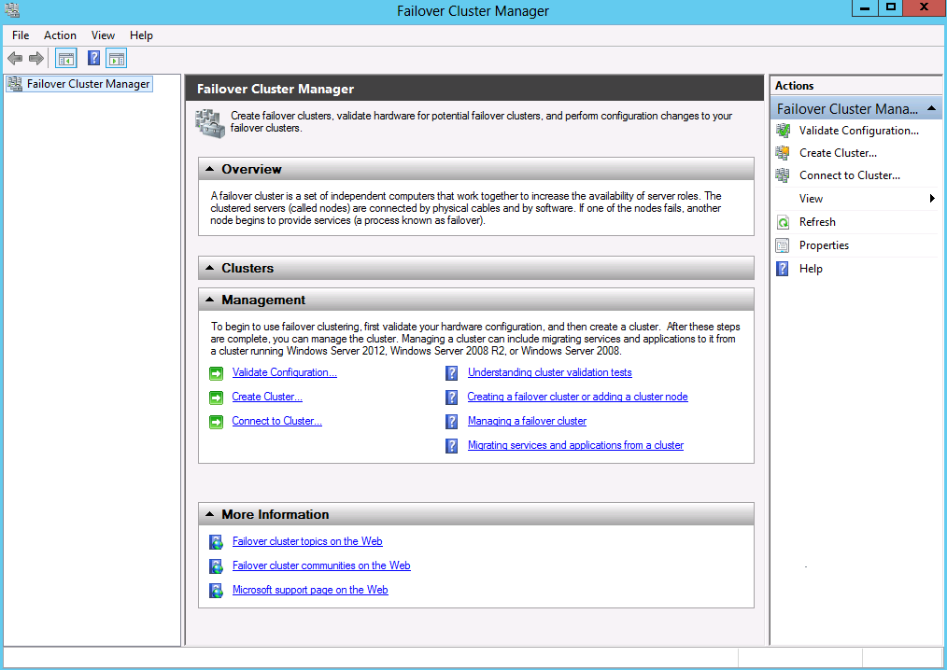

Click on the NODES to check if all my nodes are online and running.
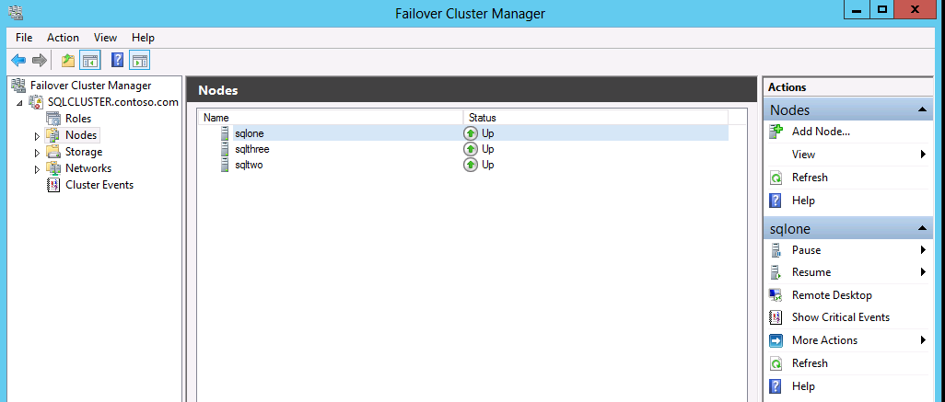

Click on the Cluster Core Resource to check the Cluster Name and check if it is up and running.


After the validation has been done, click on the Always On High Availability binder as shown in the below screen-shot. We will not be able to find any groups in there since no groups have been configured as of now.
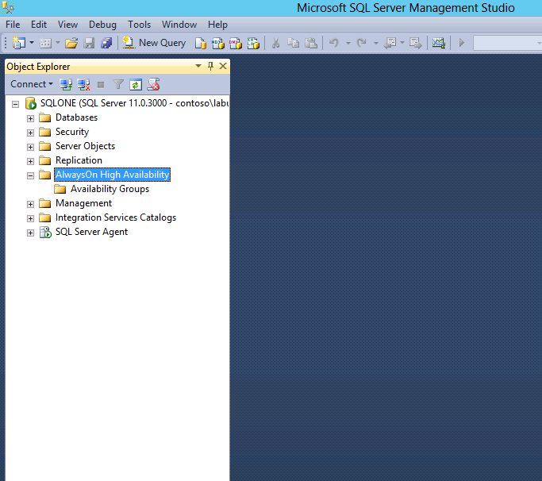

To begin with the process, right click on the Always on Availability group and choose “New Availability group Wizard”.
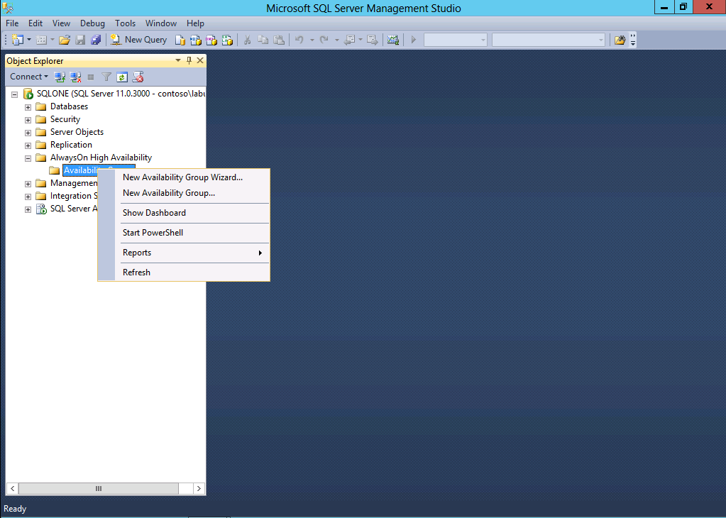

A wizard will pop up on screen and then click on NEXT option.
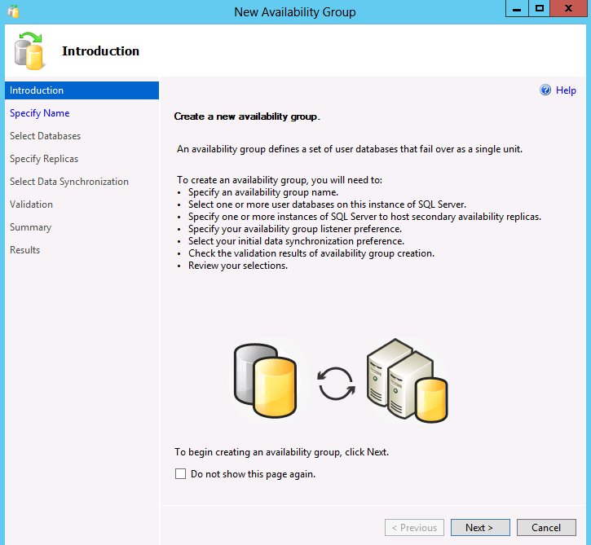
Give a name to your Availability group and click Next.
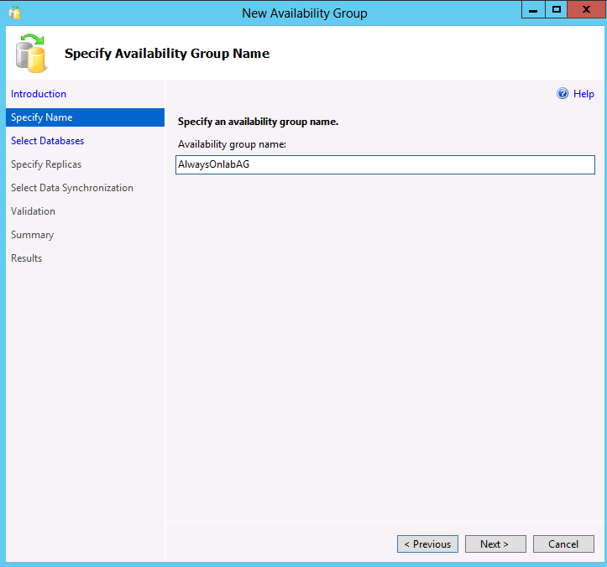
We need to choose the databases that are to be involved in the Availability Group, however there are certain conditions to be met before a database can be added to the AG (Availability Group).
Below are the conditions:
- Database must be a user database.
- Must be in the Full Recovery Model
- It should be in Multi-User mode.
- Must possess a Full database backup.
- Reside on the AG where we are configuring the Always ON AG.
- Not belong to any other AG.
- Not configured for database mirroring.

We are selecting “AlwaysONlabDB” database for our process as shown below and click next.
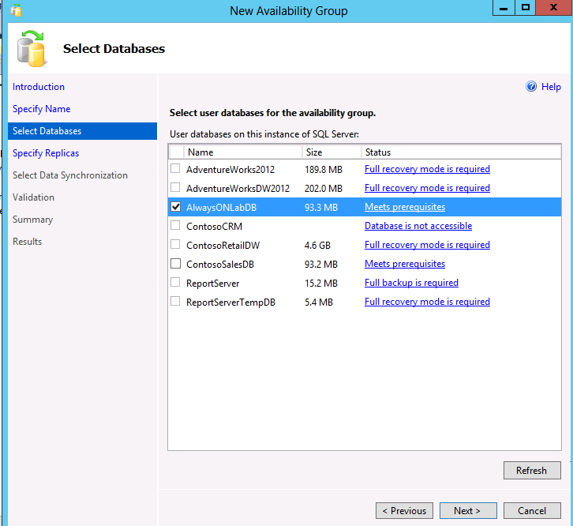

On the Specify Replica Screen we must add the replica server instances (Secondary Servers) by clicking on the “Add Replica” option to failover the services in case of disaster.
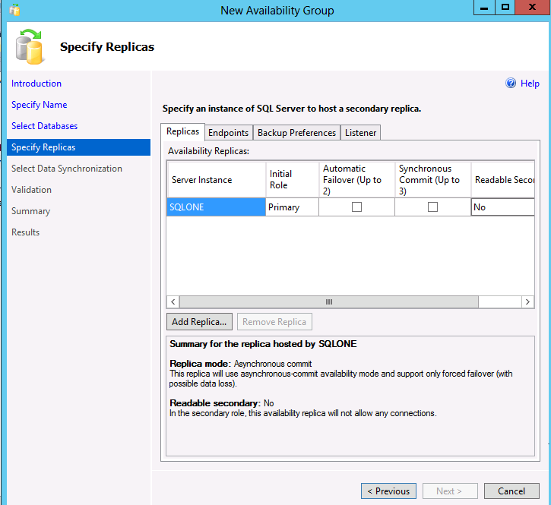
We should specify here to which server do we want automatic failover in case of Disaster occurs and the mode as well i.e., Synchronous Commit mode in present case. Click Next.
Here we are specifying SQLTWO Server for automatic failover.
*Synchronous Commit means the primary server will not commit the data/transaction until or unless it receives acknowledgement from the corresponding Replica that the corresponding log has been hardened in the disk.
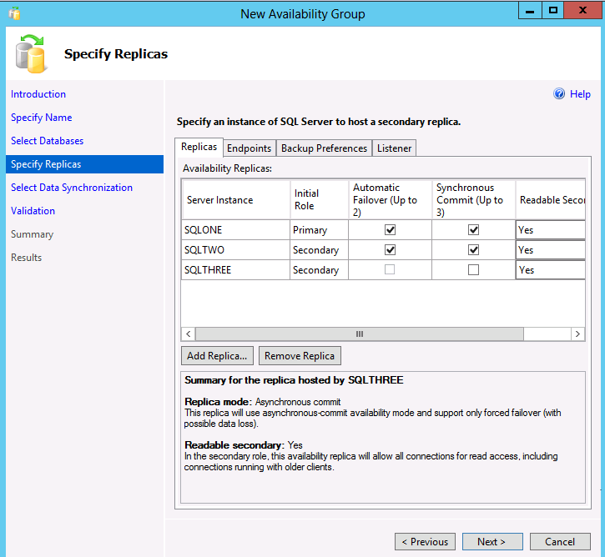

Select the type of data Synchronization you want and click Next.
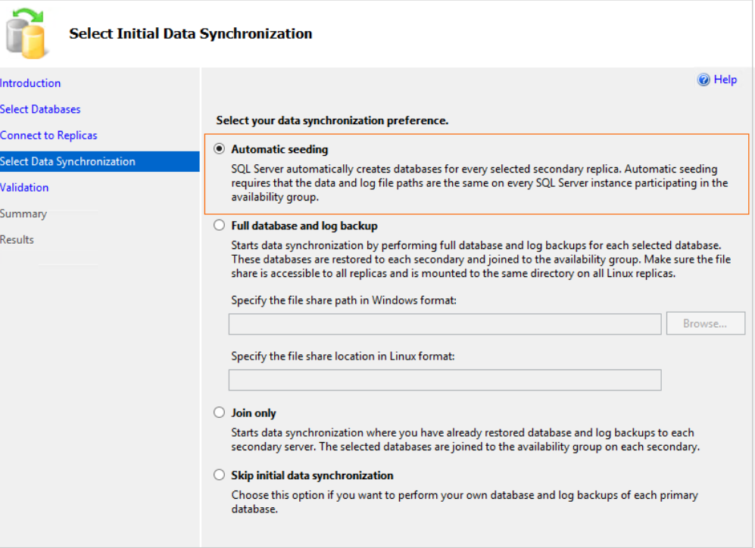
The below screen will show if all checks have been successfully validated.
Then Click NEXT.
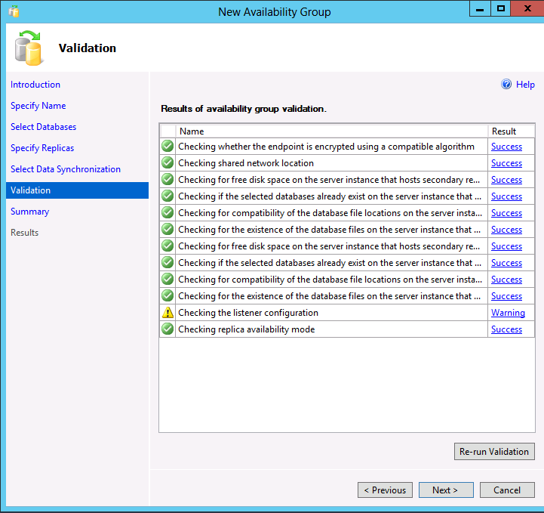

*With this you have successfully configured an AlwaysOn Availability Group*
The Next step is to configure the Listener for Availability group.
Right Click on the AG Listener and select “Add Listener.”
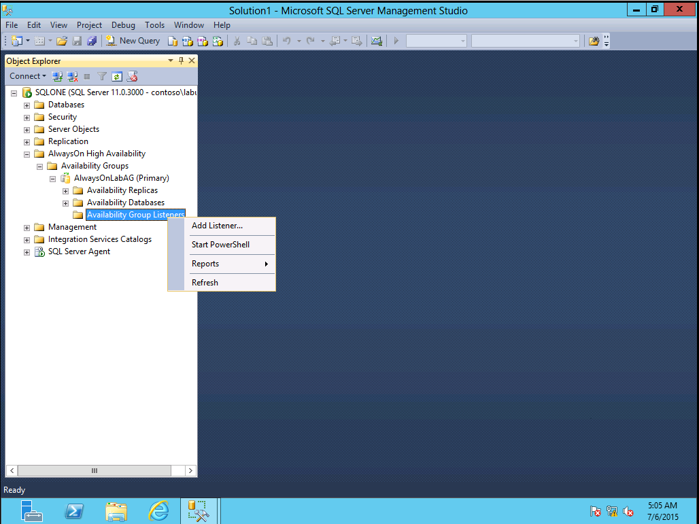

Specify the port number as 1433 and select “Network Mode” as Static IP and then click on Add button.
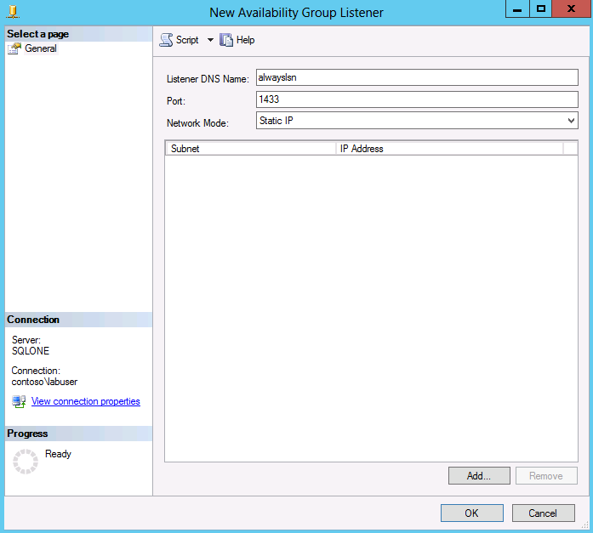
Specify the IP address.
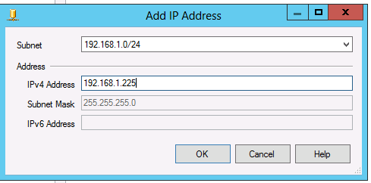

Click OK
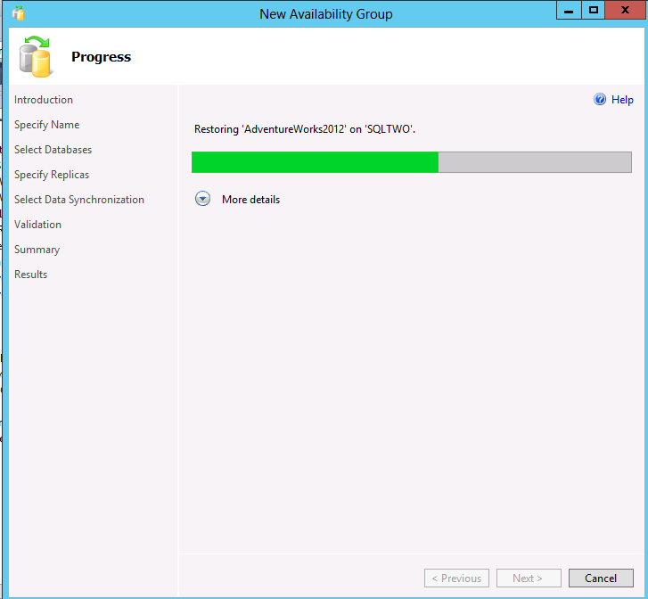

Listener would have been created by this:
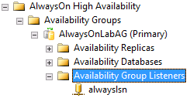

Now expand the AG tree and right click on AG name.
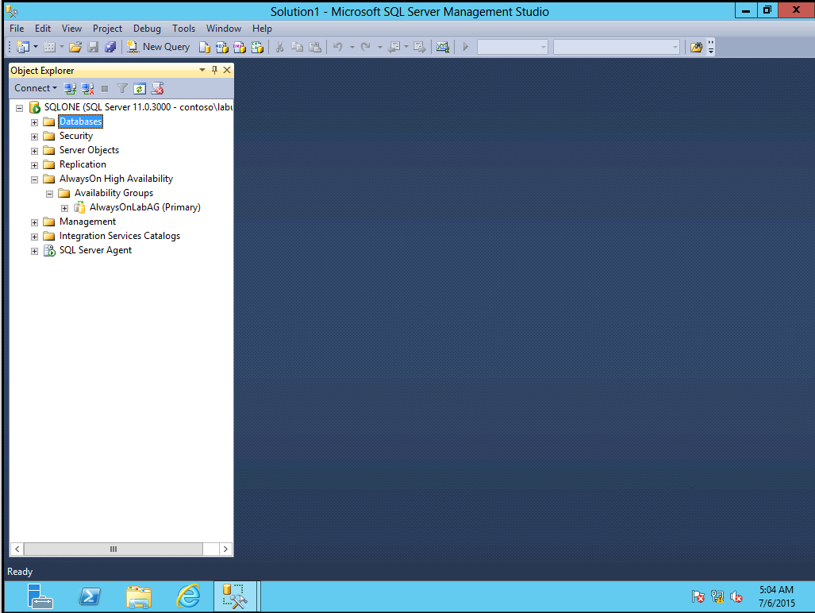

Choose the Show dashboard option.
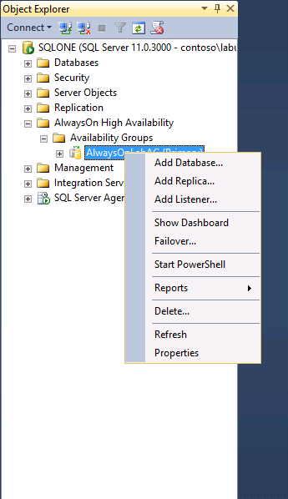
From the dashboard we can clearly monitor Always On Nodes and their states as shown in the below screenshot.

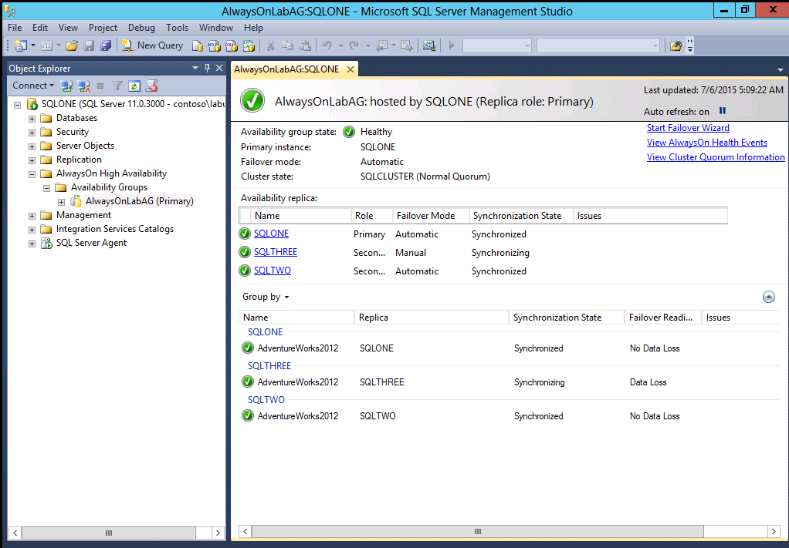

Major enhancements that happened in 2019 from 2017:
SQL 2017 introduced Linux and Docker support. This helps users to enable ‘availability groups’ on Linux based SQL Server deployments.
From SQL 2019, the support has been extended to Kubernetes as well and now SQL 2019 supports Five Sync replicas in Always On. Both the versions support cross database transactions and automatic page repair mechanisms.
There is one more feature of Read Scale AG (got introduced in SQL 2017), with the help of which we can create AG without Windows Failover Cluster, however, it will not provide High Availability.

